Project Proposal

Cryptocurrency Price Analysis

Dylan Kilkenny,

x14472008,

x14472008@student.ncirl.ie

Degree Programme Name e.g. BSc (Hons) in Computing

Data Analytics

23/10/2017

# Objectives

The purpose of this project is to investigate whether a correlation exists between the sentiment of comments on cryptocurrency forums and the price of the cryptocurrency mentioned.

# Background

Cryptocurrencies have been around since 2008. Satoshi Nakamoto, an unknown man who has never made himself known, drafted a whitepaper detailing the technical specifics of a new technology called the blockchain. The blockchain would go on to be the powerhouse that would drive a revolution of digital currencies. Satoshi built

# Technical Approach

Brief description of the approach to be followed (Max. 1 Page), Research, literature review, requirements capture, implementation etc…

I will begin by researching previous attempts at cryptocurrency price analysis using crowd sentiment. I will also research methods for sentiment analysis of comments. For the purpose of this project i will be focusing my attention on a select few forums to gather comments; bitcointalk.org, reddit.com/r/btc, reddit.com/r/cryptocurrency and reddit.com/r/bitcoinmarket. Reddit.com offers a public api which allows me to grab comments and metadata without much work required. For querying the api I will use python and an open source python wrapper for Reddit’s api. Bitcointalk.org is one of the largest cryptocurrency related forums on the internet and unfortunately there is no api. This will require me to build a python script with selenium to crawl their site and mine the data. I will also require current and historical price data for the top 50 cryptocurrencies. This data is available from coinmarketcap.com’s public api.

# Special resources required

If applicable, e.g., books, hardware, etc.

None

# Project Plan

Gantt chart using Microsoft Project with details on implementation steps and timelines

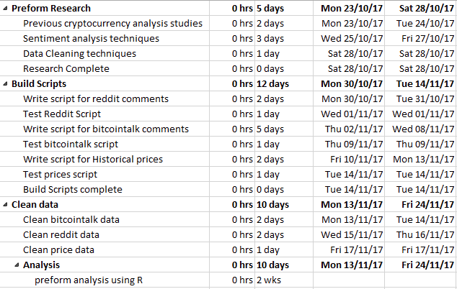

# Technical Details

Implementation language and principal libraries

Mining the comments from reddit and bitcoin talk will require me to use python and its libraries selenium and requests. For analysing the comments and prices i will be using R.

# Evaluation

Describe how you will evaluate the system with real technical data using system tests, integration tests etc. In addition, where possible describe how you will evaluate the system with an end user.

**I/we acknowledge that I/we have read, understood and agree with this form and the Institute’s *Intellectual Property and Procedures* and that all the information provided in this disclosure is complete and correct.**

**I/we shall take all reasonable precautions to protect the integrity and confidentiality of the IP in question.**

Inventor: ______________________________ _______________________

Signature Date

_____________________

Signature of student and date